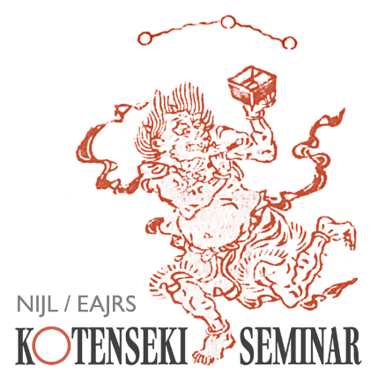

The National Institute of Japanese Literature (NIJL) and European Association of Japanese Resource Specialists (EAJRS) would like to invite you to the second Kotenseki Seminar. This year, we will examine Japanese pre-modern books on Buddhism.
Our speaker will explain the characteristics of those books, give a general synopsis of the books, and show how to catalogue them.
The Seminar will be given in Japanese without interpretation.

Date | 10:00-12:15 Central European Summer Time  Friday, 18 October 2024  (There will be a break hourly, and a Q&A session at the end)
Speaker | Associate Professor Davin Didier  (National Institute of Japanese Literature)
Admission | Free
Application Form | Click here for the form
Deadline | 10 October 2024

This seminar will be recorded and made available later on YouTube.
For further enquiries about this Seminar, please contact Akira Hirano at: a.hirano@sainsbury-institute.org
We look forward to your participation.

